Date | 27 June 2026
Team ID
Project Name | Student Leave Request Automation
Maximum Marks
Project Development Phase

1. Introduction
The Student Leave Automation System was developed as a scoped application on the ServiceNow platform. The objective of the implementation phase was to automate the student leave approval process by replacing manual paperwork with a centralized workflow. The application provides separate interfaces for students and faculty, role-based access control, workflow automation, and email notifications.

2. Milestone 1 – Application Setup
Objective
Create the scoped application and initialize the project.
Activities Performed
- Created a new scoped application.
- Configured the application menu and modules.
- Prepared the development environment.
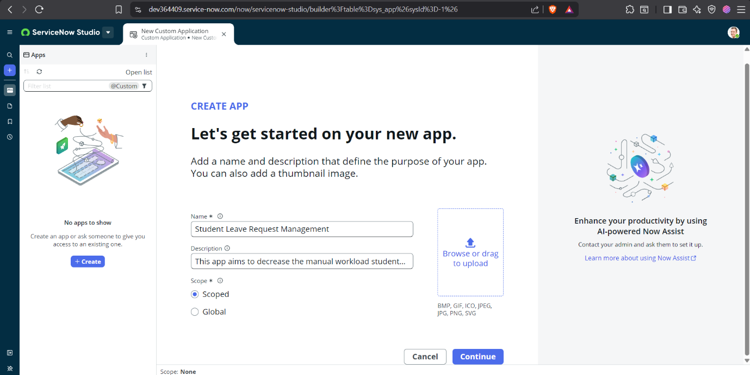

3. Milestone 2 – Database Configuration
Objective
Create the Leave Request table for storing leave applications.
Activities Performed
- Designed the Leave Request table.
- Added fields such as Student, Class Teacher, HOD, Leave Type, From Date, To Date, Status, Approved Days, and Comments.
- Configured reference fields to the ServiceNow Users table (sys_user).
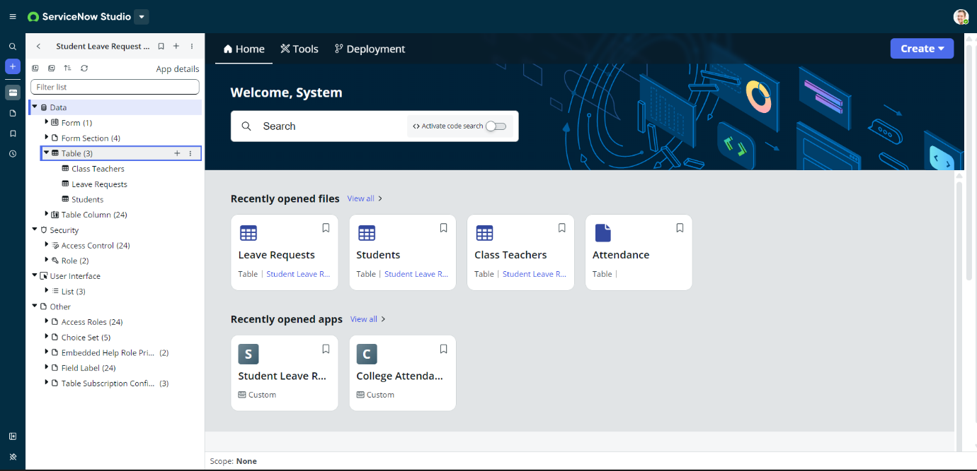
4. Milestone 3 – User & Role Configuration
Objective
Configure users and application roles.
Activities Performed
- Created student user accounts.
- Created faculty user accounts.
- Assigned App User role to students.
- Assigned App Admin role to Class Teachers and HODs.
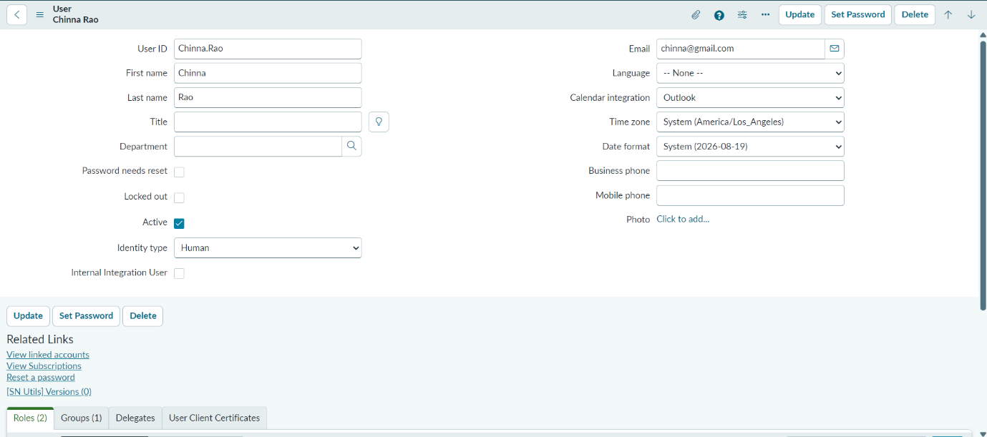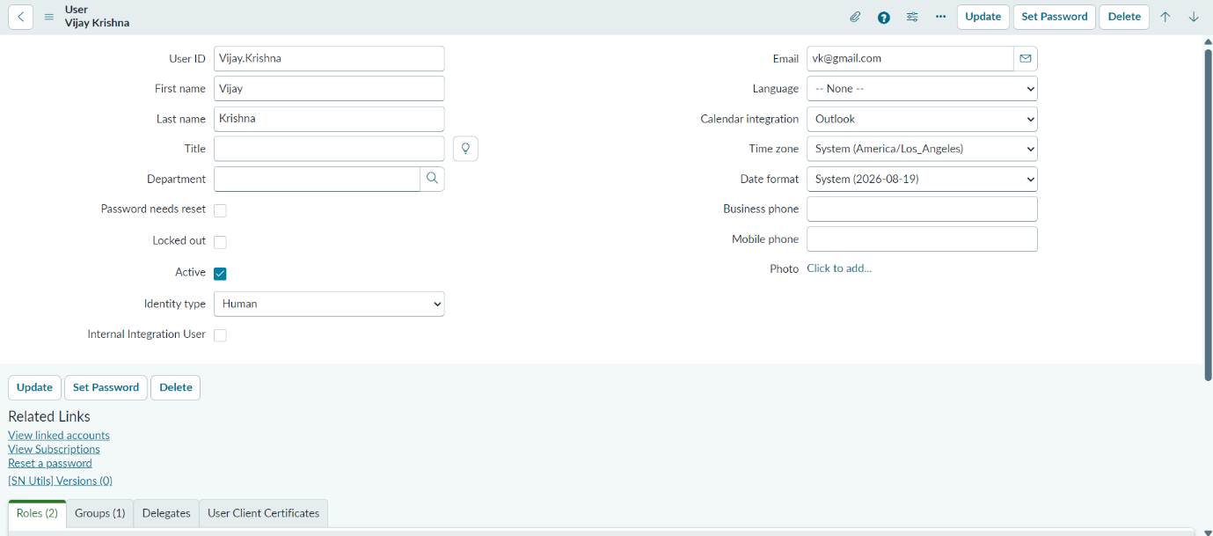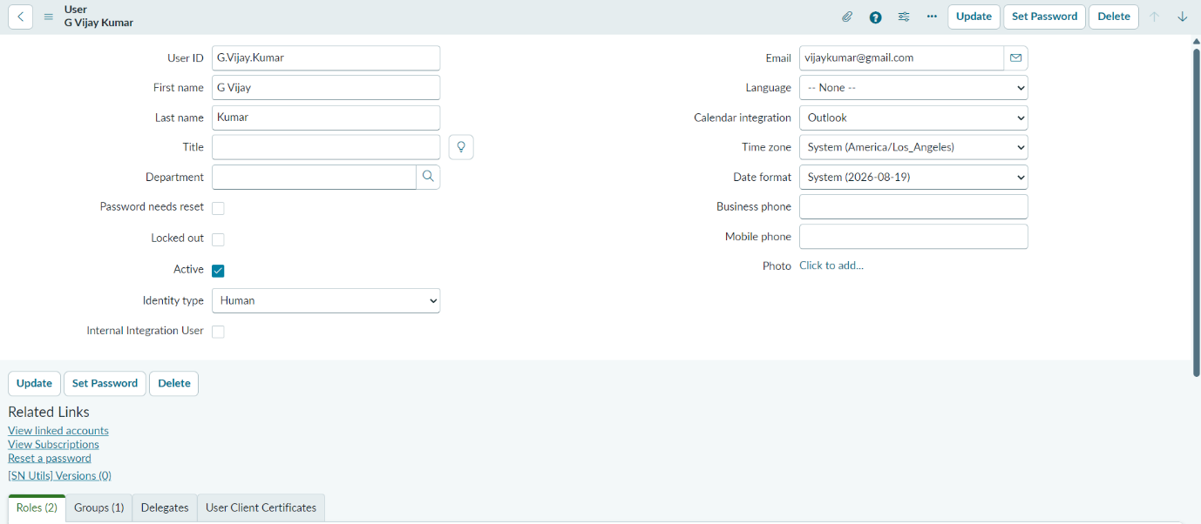
5. Milestone 4 – User Interface Development
Objective
Develop user-friendly interfaces for students and faculty.
Activities Performed
- Designed the Student Leave Request form.
- Configured separate Student and Faculty views.
- Implemented UI Policies for dynamic form behavior.
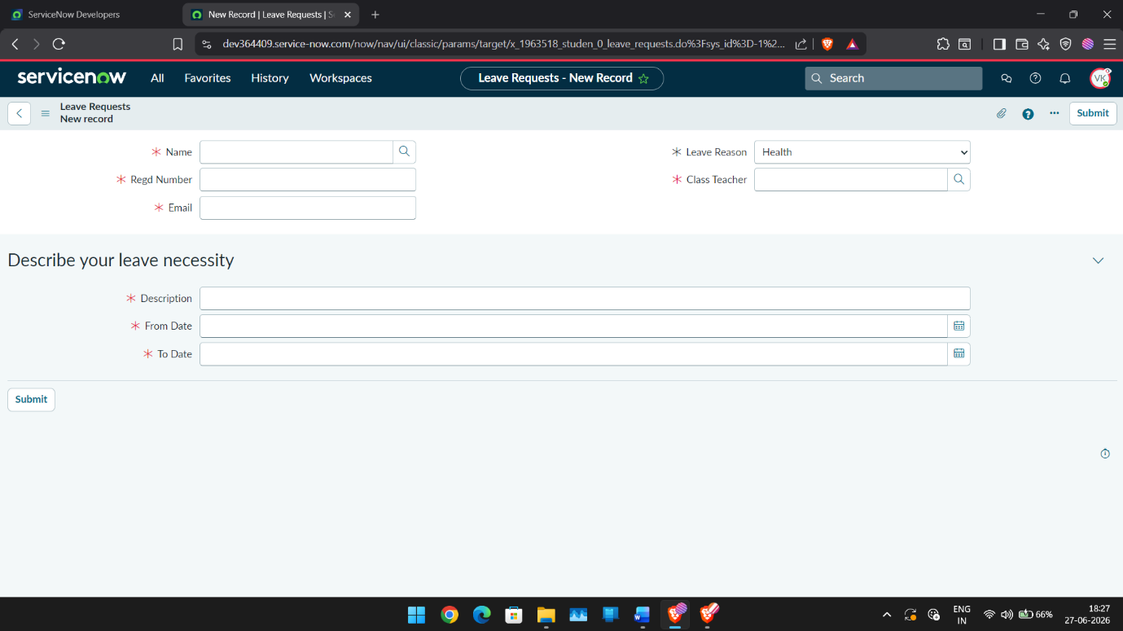
6. Milestone 5 – Workflow Automation
Objective
Automate leave approval notifications.
Activities Performed
- Developed a Flow Designer workflow.
- Triggered the workflow whenever the leave status changes.
- Configured notification logic for Approved, Rejected, and Escalated states.
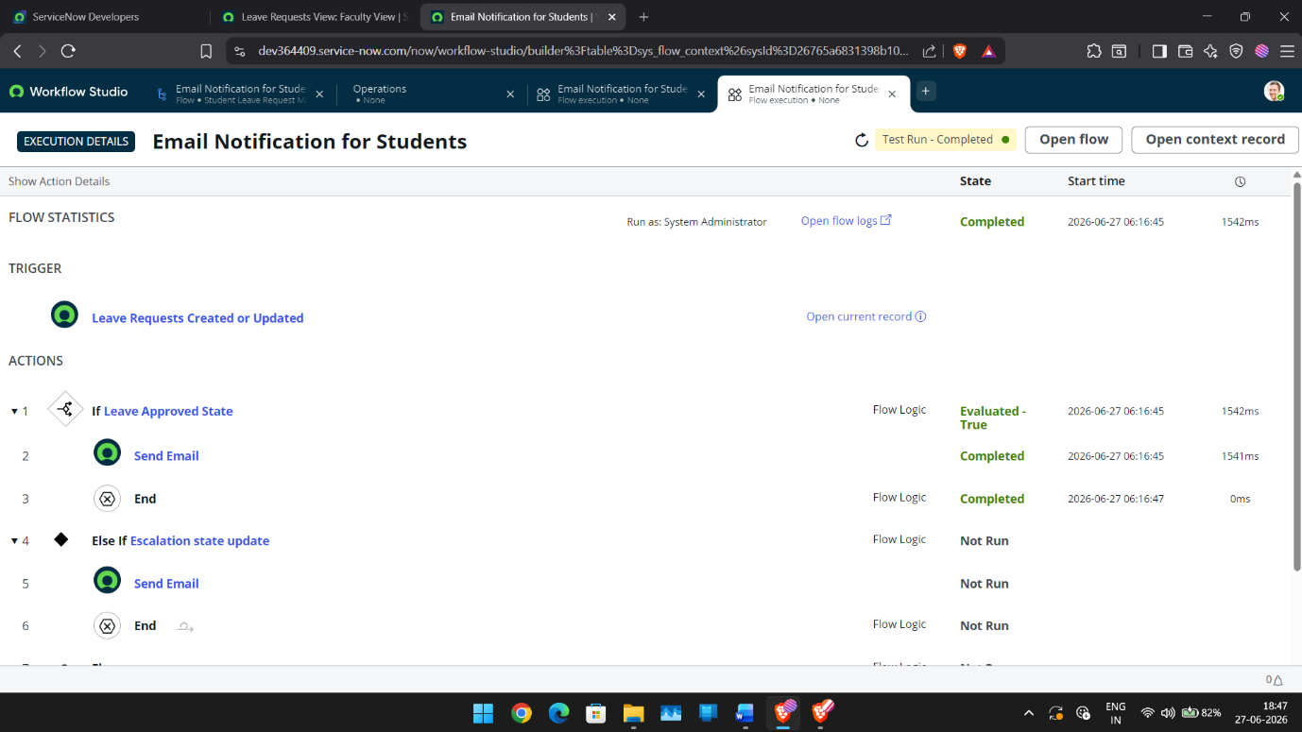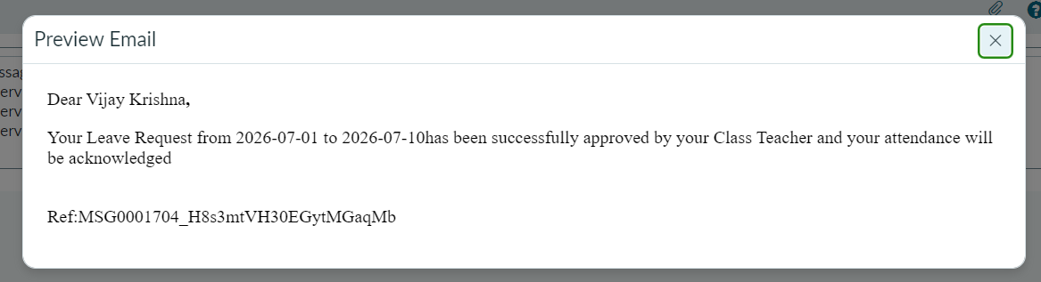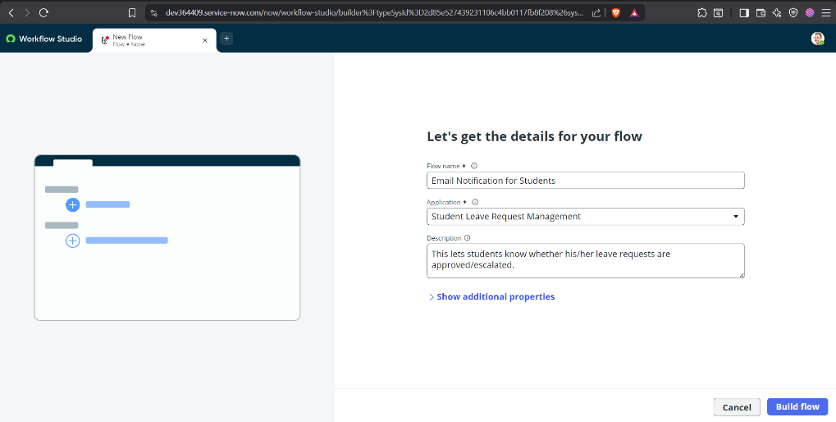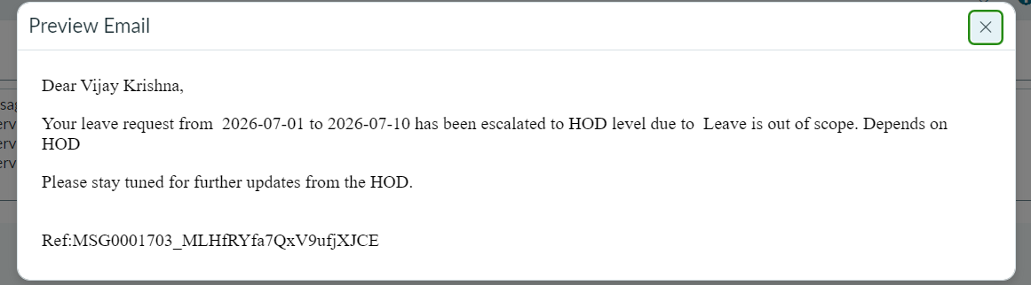

7. Milestone 6 – Application Testing
Objective
Validate the end-to-end functionality of the application.
Test Scenario 1
Student submits a leave request.
Expected Result:
Leave request is created successfully.
Status:
Passed
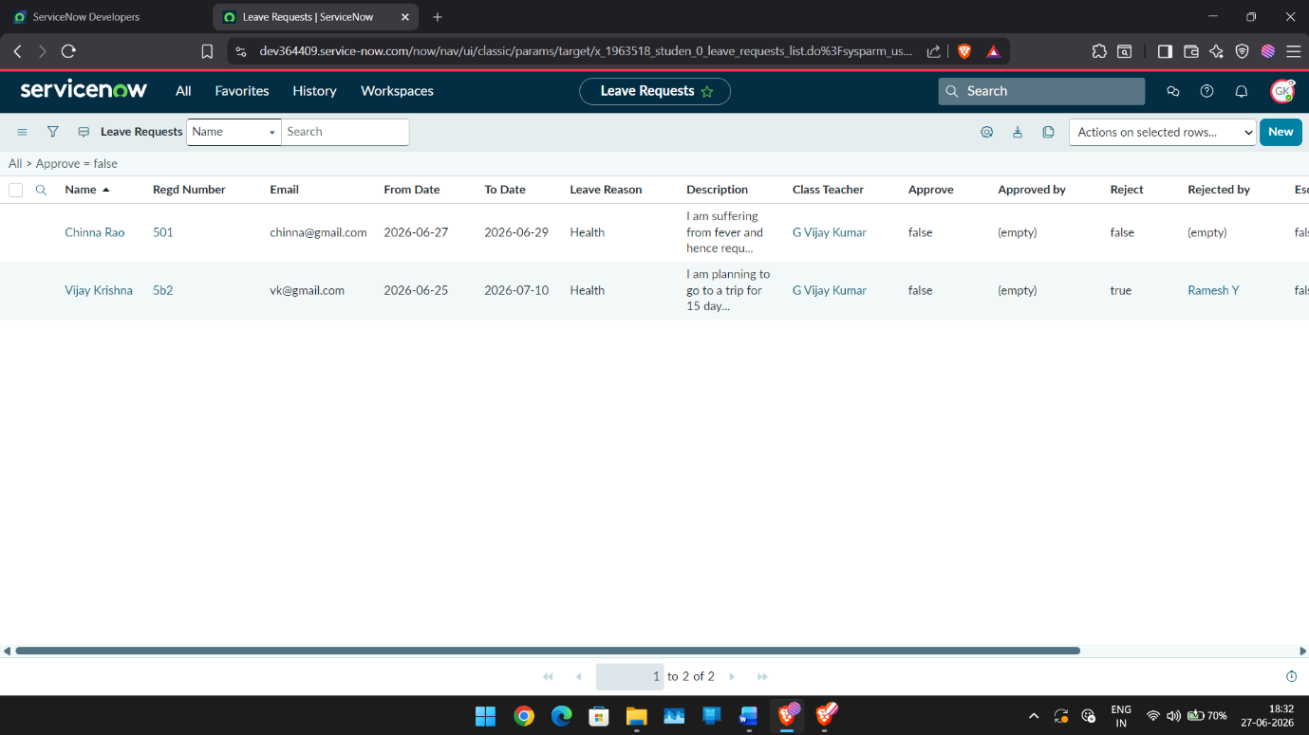

Test Scenario 2
Class Teacher approves a leave request.
Expected Result:
Status changes to Approved and an email notification is sent.
Status:
Passed

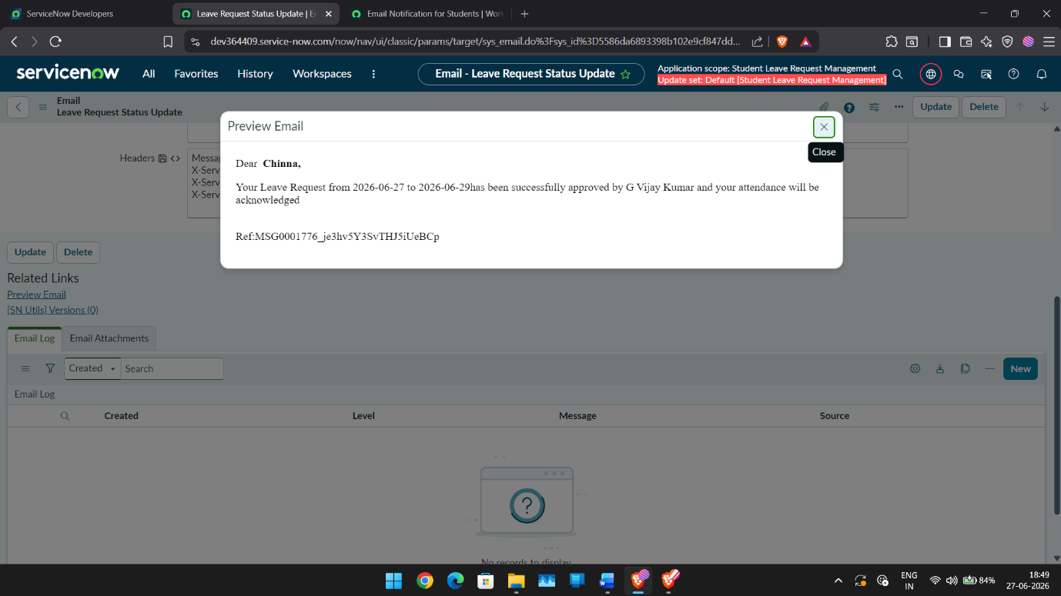

Test Scenario 3
Class Teacher manually escalates a leave request exceeding five days.
Expected Result:
Request is forwarded to the HOD and an escalation email is sent.
Status:
Passed



Test Scenario 4
Faculty impersonation testing.
Expected Result:
Faculty can only access assigned leave requests.
Status:
Passed
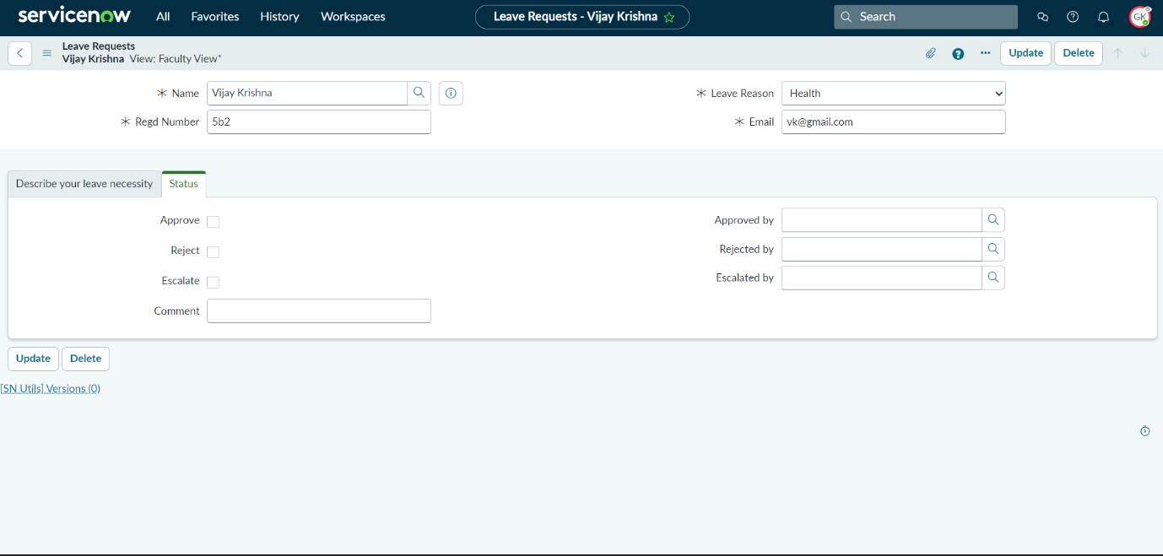

8 Development Summary
The Student Leave Automation System successfully implements a centralized leave management workflow using ServiceNow. The application integrates role-based access control, separate student and faculty interfaces, workflow automation through Flow Designer, and email notifications. All major functional requirements were implemented and validated through successful testing.

